Payment Advice (Supplier Remittance) Trigger – CRIM 0556

|  |  |  |  |  |
| --- | --- | --- | --- | --- |
| **Ver** | **Date** | **Author** | **Comments** | **Reviewed by** |
| 1 | 25/03/2021 | Tom Bell | CRIM 0556 | TBC |
|  |  |  |  |  |

Requirements 2

Prerequisites 2

Solution Overview 2

Solution Details 2

Security 3

Companies 3

Data Migration 3

Test Steps 3

Technical Implementation 3

Requirements

The trigger of the creation of the Supplier Payment Advice (Supplier Remittance) needs to be changed to be triggered after the Supplier Payment Order has been set to Acknowledged.

Solution Overview

Currently the generating and sending of the Supplier Payment Advice (Supplier Remittance) is at creation of the Payment Order as per the setting below.

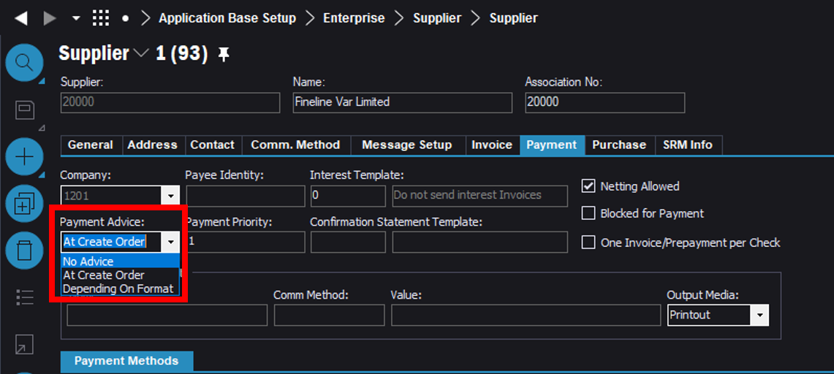

The trigger of the creation of the (Payment Order) Supplier Remittance needs to be changed to be triggered after the Supplier Payment Order has been set to “Acknowledged”. Currently, when a Payment Order is created the Payment Advice is automatically generated and sent out the Supplier.

Instead one of the following options must occur.

1. At creation of the Payment Order the Supplier Payment Advice is only generated and stored temporarily in a report archive. When the Payment Order is “Acknowledged” then the Payment Advice is sent out the Suppliers via email.
2. Or when the Payment Order is “Acknowledged” the Payment Advice (Supplier Remittance) is generated AND sent out the supplier via email.

Solution Details

The below screenshot shows the RMB option of “Entering the Acknowledge of Payment”.

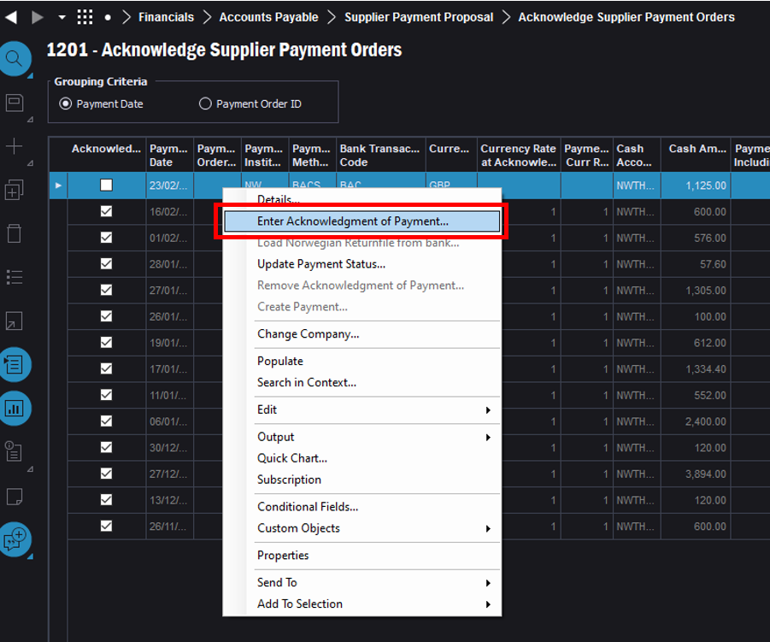

Once “OK” is selected (red in below screenshot) then the Payment Advice (Supplier Remittance) must be sent out to the Supplier via email.

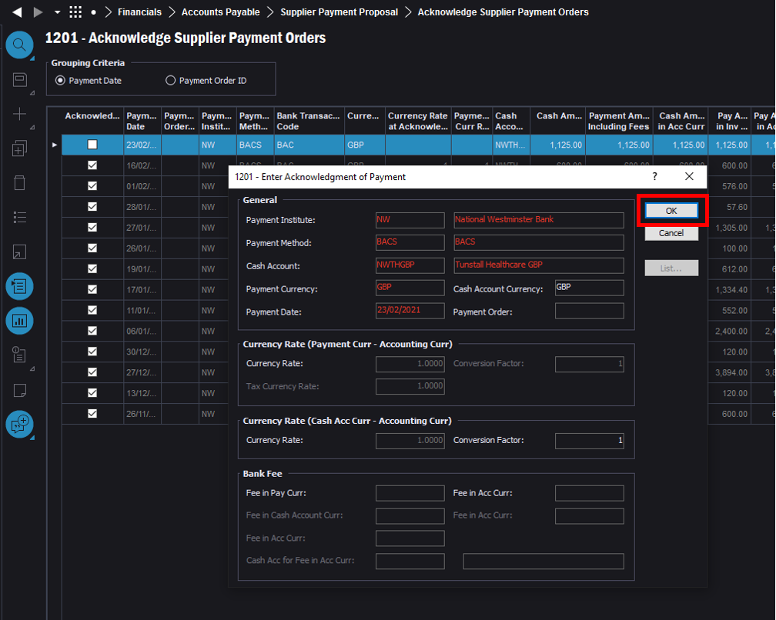

**Technical.**

Field Definitions.

<New Field/CLU Definition>

|  |  |  |  |  |  |  |
| --- | --- | --- | --- | --- | --- | --- |
| New DB Object Name | DB Object Item/Field Names | Item Description | Item Data Type | Item Syntax | Calculation Spec, if Derived | LOVs/Enums/Is Mandatory? |
|  |  |  |  |  |  |  |
|  |  |  |  |  |  |  |
|  |  |  |  |  |  |  |
|  |  |  |  |  |  |  |
|  |  |  |  |  |  |  |
|  |  |  |  |  |  |  |
|  |  |  |  |  |  |  |
|  |  |  |  |  |  |  |
|  |  |  |  |  |  |  |
|  |  |  |  |  |  |  |
|  |  |  |  |  |  |  |
|  |  |  |  |  |  |  |

Security

All users with access to Supplier can access/ view and edit this field.

Companies

Applies to the following companies. All.

|  |  |
| --- | --- |
| **Company** | **Required (Y/N)** |
| 1201 | Y |
|  |  |
|  |  |

Data Migration

N/A

Test Steps

<Steps that needs to be taken to test this change. Please provide expected results> Updated post solution.

|  |  |  |
| --- | --- | --- |
| **No** | **Script\Test Steps** | **Expected Result** |
| 1 | Change Payment Advice method to ‘depending on format’ in Supplier, payment. | Mail to be sent when the advice is acknowledged. |
| 2 | Change Grouping criteria from Payment Date to Payment Order ID | Payment Order ID requires an entry. |
| 3 | Acknowledge the Supplier Payment Orders | Mail sent to supplier with attach Supplier Advice. |

Technical Implementation

This implementation uses following Custom Objects.

Custom Event: SUPPLIER_PAYMENT_ADVICE

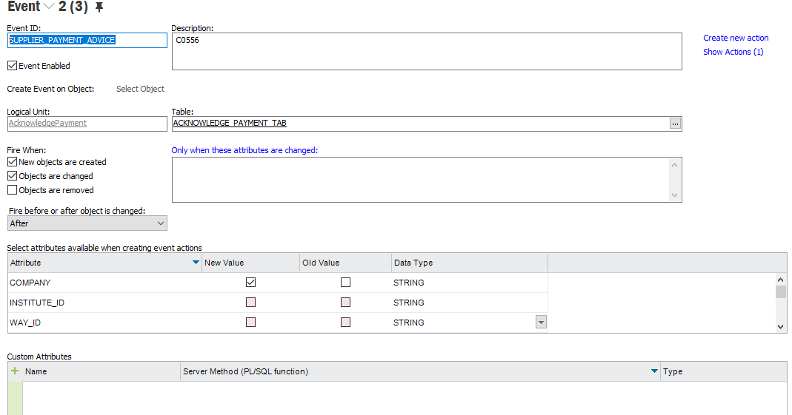

Event Action:

